Francisco lopez 5/23/17

1.Energy resources are sources that can conduct electricity or power such as wood. Coal, or gas.

2. Renewable and nonrenewable are different because nonrenewable are energy sources that are will eventually run out and will not replenish resources such as coal, petroleum and natural gas. Renewable recourses are energy from natural resources such as sunlight, water, and wind.

3a. One renewable resources is sunlight also plants uses sunlight energy like photosynthesis, plants convert sunlight energy and turn into chemically stored energy. A nonrenewable resource is fossil fuel but it's not one thing because coal, oil and natural gas are all a fossil fuel because it fuel that is formed by the remains of buried animals and plants that lived millions of years ago.

3b.The advantages of fossil fuel is that it is affordable and abundant, the disadvantage is that they can’t be replaced and can’t be revitalized and can causes greenhouse gases.

The advantages of using sunlight is that it's there it's not going away for billions of years and solar panels need very little maintenance. The disadvantage is that energy can’t be created in the night and power is reduced when a cloud covers the panels.

3c. sunlight(solar energy)

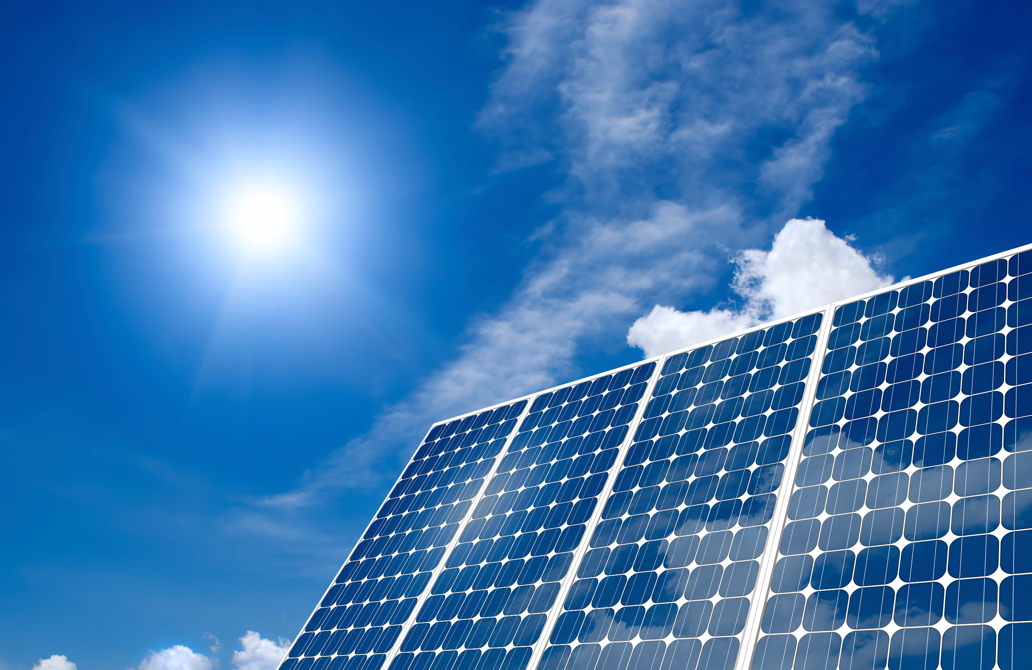

3c. Fossil fuel(oils,coal,natural gases)

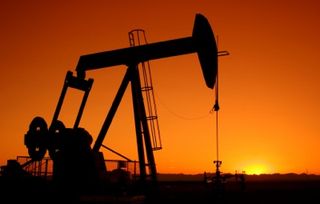

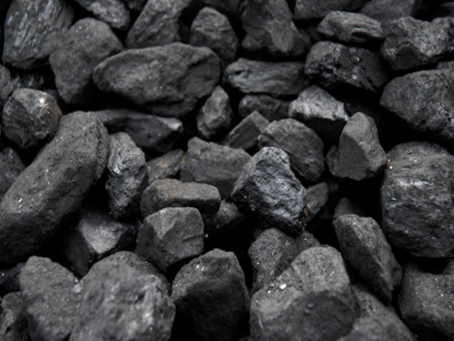



4. Fossil fuels environmental issue is that it can cause pollution and harm local communities and also emit highly dangerous toxins.

Sunlight can heat the earth’s surface, but when there is too much heat it can cause global warming and it's very dangerous to the earth and people.